ESERCIZIO 5
- Configure VTP
- Configure VLANs
- Configure trunking and verify VTP status (using show VTP status, show VTP password)
- Assign VLANs to access ports
- Verify connectivity
Scenario
In this exercise, you will practice configuring VTP and VLANs and establishing trunk links. In addition, you will assign VLANs to access ports and then test connectivity between devices on the same VLAN. The PCs are already configured with IP addressing. The switches have a basic configuration like hostname configuration.
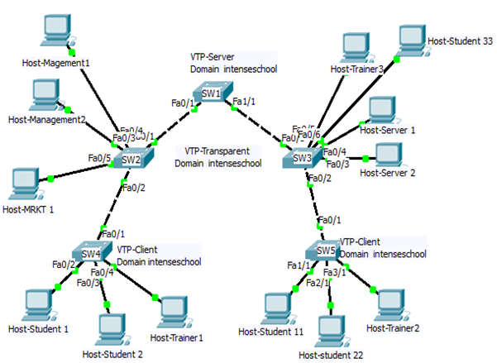
Tasks to perform:
- Configure the SW1 switch as a VTP server
- Configure SW2 VTP Transparent and SW3, SW4 and SW5 should act as VTP client. All links between switches must be configured as trunk links and links connected to hosts should be in proper VLANs and must configure as Access.
- Configure VTP domain name as “intenseschool” and VTP password as “cisco”
- Configure VLAN 10 with name “STUDENTS.” Configure VLAN 20 with name “TRAINERS” and VLAN 50 with name “SERVERS” on VTP SERVER only means on SW1.
- Configure VLAN 100 with the name “MARKETING” and VLAN 200 with name “MANAGEMENT” on Transparent switch only means on SW2
- Check propagation on client switches of the VTP domain
- All computers are preconfigured with proper IP address with:
N/W 10.1.10.0/24 for Students (VLAN 10)
N/W 10.1.20.0/24 for Trainers (VLAN 20)
N/W 10.1.50.0/24 for Servers (VLAN 50)
N/W 10.1.100.0/24 for Marketing (VLAN 100)
N/W 10.1.200.0/24 for Management (VLAN 200)
Task 1: Configure VTP
Step 1: Configure VTP on the switches. Do not configure VLANs yet.
Step 2: On completion check with show VTP status & show VTP password.
Task 2: Configure VLANs
Step 1: Configure VLANs on the VTP server only.
Step 2: Configure trunking and verify VTP status.
Step 3: After completing the first two steps, check with show VLAN command on server and clients to verify your configuration.
Note: VTP advertisements are flooded throughout the intenseschool domain every five minutes or whenever a change occurs in VLAN configurations.
Task 4: Assign VLANs to Access Ports
Step 1: Configure access ports and assign VLANs for the PCs. Be sure to activate the links.
Step 2: On completion you can verify it with show VLAN.
Task 5: Verify Connectivity
All switches should now be able to ping each other. PCs belonging to the same VLAN should be able to ping each other.
Task 6: Save the Packet Tracer File

